Chapter 2, Solution 18

Find I and V_{ab} in the circuit of Fig. 2.82.

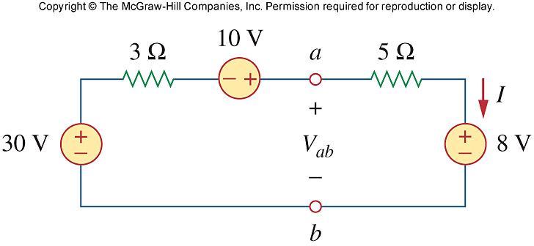

Figure 2.82
For Prob. 2.18.

Solution

Applying KVL,

-30 -10 +8 + I(3+5) = 0

8I = 32 I = 4A

-V_{ab} + 5I + 8 = 0 V_{ab} = 28V

